Mazen Adel Jamel Abuljadayel Mazoon33@hotmail.com 0569130960

**MVP for King Abdul-Aziz Airport Slots Management Utilization**

Bootcamp

**MVP**

We need to answer the two main Data Science questions by providing the Available Slot capacity and the value of return.

Below the slot management process:

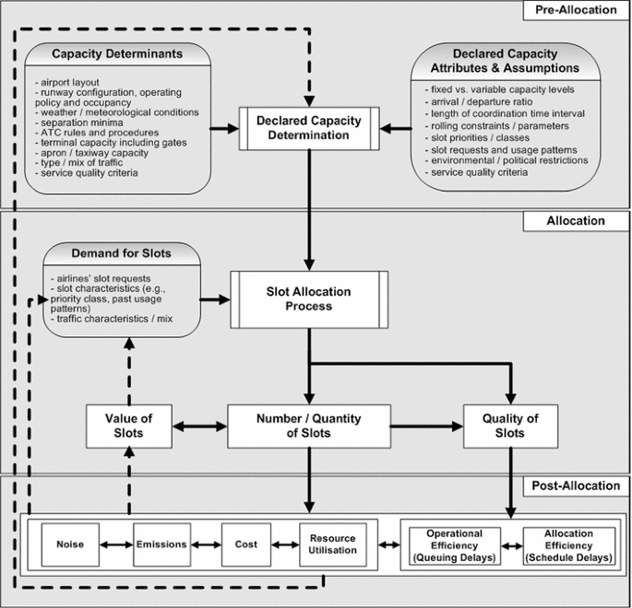

Slot Availability:

